1 Result Analysis
1.1 Algorithm Comparison (ablation study):
The comparative study revealed significant differences in how different algorithms handle multidimensional text.
The failed Baselines: To find the most accurate way to map these papers we conducted a test using several different algorithms to reduce the dimensionality and clustering. Our data set being 47000 text and 768 dimensional vector generated by SciBERT, old methods like PCA proved insufficient, yielding the lowest Silhouette score in all the tests (0.07). Resulting very poor, overlapping clusters.
We also tested a deep learning approach by pairing HDBSCAN with PyTorch Autoencoder. This yielded the best Silhouette score (0.756) with minimal noise (0.9%) but failed and scored a negative in Adjusted Rand Index (ARI) which was basically zero (-0.0032). We found it successfully grouped the papers together on irrelevant features than the actual academic topics.

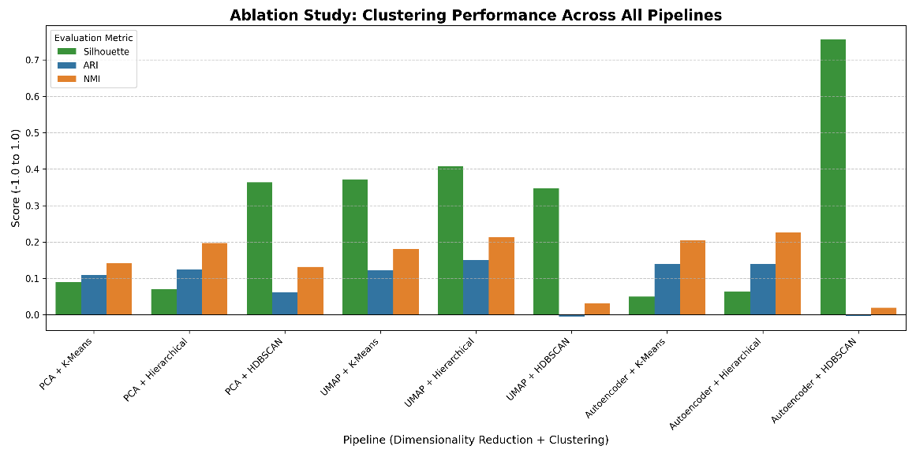
Fig. Comparative ablation study of clustering performance, highlighting the difference between Silhouette and ARI/NMI.

The Optimal Pipeline: UMAP with Hierarchical Clustering emerged as the clear winner. It successfully balanced the cluster density with a high Silhouette score (0.4076) while scoring the highest Adjusted Rand Index of (0.150) across all the tests. Which proved it to be the most capable pipeline for accurately detecting the boundary of AI and medicine.
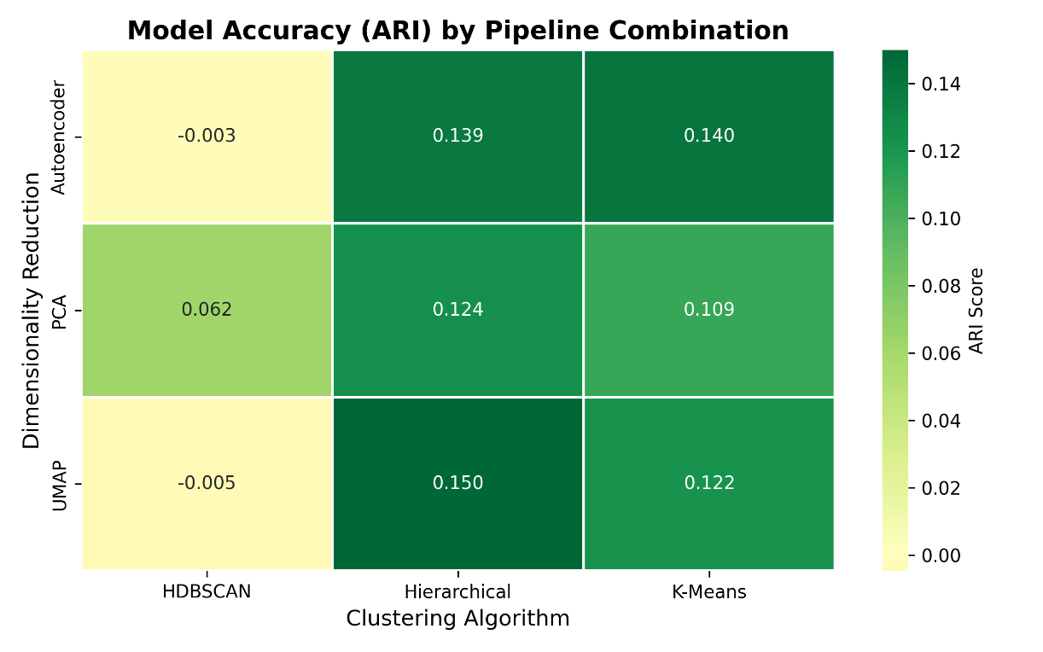
Fig. Heatmap demonstrates the Adjusted Rand Index (ARI) accuracy across all dimensionality reduction and clustering pipelines.

1.2 Cross-Domain Knowledge Mapping (k=4)
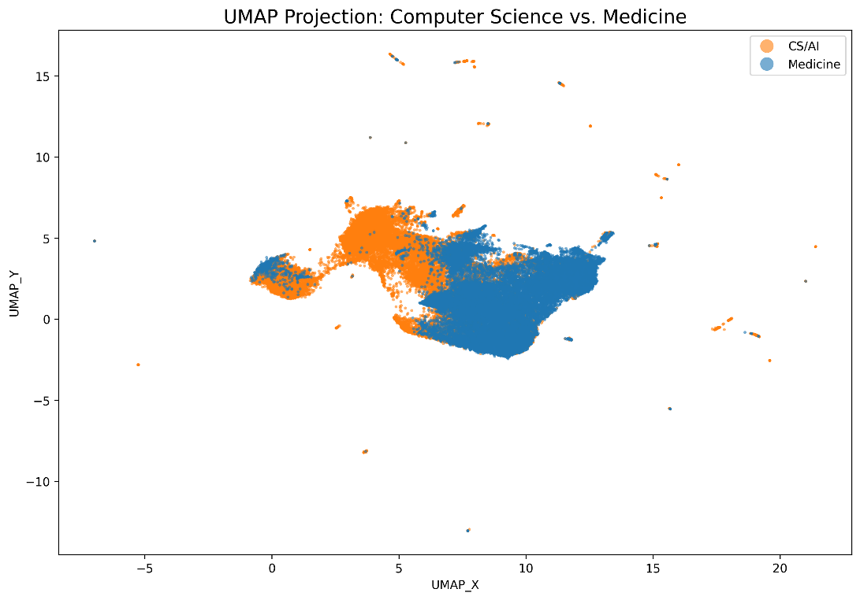
Fig. UMAP of 47,003 abstracts, color-coded by their domain

After proving that UMAP and Hierarchical Clustering was the best pipeline, we used it to map all 47000 abstract into four distinct categories. By analyzing the ratio of Computer Science to Medicine papers by 80-20 method with their top tf-idf keywords, we found what these categories represent.
Cluster 0: AI-Dominant
- Demographics: 85.3% AI (total 15,587 papers)
- Keywords: ai, data, learning, social, health, analysis
- Analysis: This cluster represent the large scale machine learning side of the general healthcare system and electronic health records which researchers are focusing on.
Cluster 1: Medical-Dominant
- Demographics: 83.4% Medicine, 16.6% AI (total 8,136 papers)
- Keywords: patients, ct, mri, 3d, volume, images
- Analysis: This cluster represents the purely medical side of the papers, where doctors are using imaging tools directly on human for diagnostics.
Cluster 3: AI-Dominant
- Demographics: 92.1% AI (total 4,716 papers)
- Keywords: brain, cognitive, functional, connectivity, cortex
- Analysis: Even if the keywords are biological this clusters shows the isolated field of Computational Neuroscience where computer scientists builds ai to simulate inner workings of the brain.
Cluster 2: Overlap of AI and Medicine Domain
- Demographics: 32.4% AI, 67.6% Medicine (total 18,561 papers)
- Keywords: segmentation, image, medical, model, method, proposed, learning
- Analysis: This is the nexus of our study. Containing over 18,500 papers, this massive cluster represents the exact point where the two domains collide. The keywords we see in this field is the perfect mix of computer science and medical domain. Which proves when medical and computer domain collide they maintain a specific vocabulary focused entirely on training ai models on medical images.
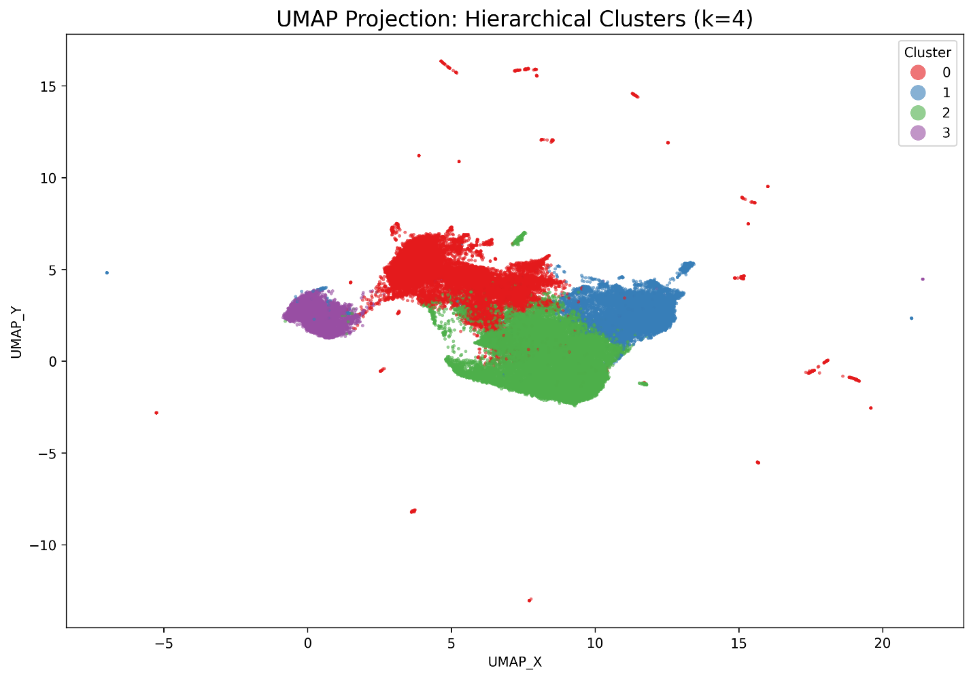fig Unsupervised Hierarchical Clustering (k=4) revealing the four distinct territories, including the shared overlap in Cluster 2.

